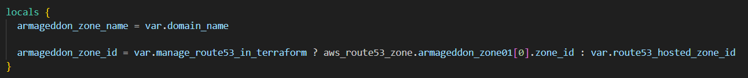
- armageddon_zone_name is just an alias for your domain (like example.com).
- armageddon_zone_id decides where DNS records should be created:
  - If var.manage_route53_in_terraform = true, Terraform will create the hosted zone (aws_route53_zone.armageddon_zone01) and use its zone_id.
  - If false, Terraform will not create a hosted zone, and you must supply an existing one via var.route53_hosted_zone_id.
Key idea: everything later that creates DNS records uses local.armageddon_zone_id, so your code can work in both “Terraform manages Route53” and “Route53 already exists” setups.
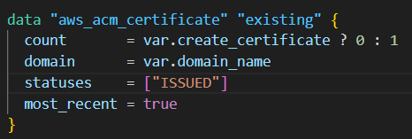
- This is a data source, meaning “read something that already exists in AWS.”
- It only runs when var.create_certificate = false because of:
  - count = var.create_certificate ? 0 : 1
- It searches ACM for a certificate matching:
  - domain = var.domain_name
  - status must be ISSUED
  - pick the newest one (most_recent = true)
Outcome: If you’re not creating a cert, it grabs an existing issued cert ARN for later use.
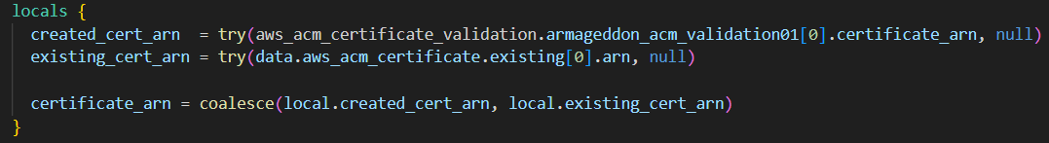
This creates a single “final answer” value: local.certificate_arn.
- try(..., null) prevents Terraform from erroring if that resource/data doesn’t exist (because of count = 0 cases).
- created_cert_arn:
  - tries to read the ARN from the certificate validation resource (meaning: you created a new cert and validated it).
- existing_cert_arn:
  - tries to read the ARN from the data source (meaning: you’re using an already-issued cert).
- coalesce(a,b) returns the first non-null value.
  - So Terraform uses the created cert if it exists; otherwise it uses the existing one.
Outcome: other parts of your Terraform can just reference local.certificate_arn without caring which path you took.
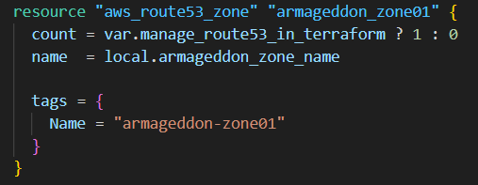
Hosted zone is only created if manage_route53_in_terraform = true.
If it’s false, Terraform won’t touch Route 53 hosted zones (but can still create records if you provide route53_hosted_zone_id).
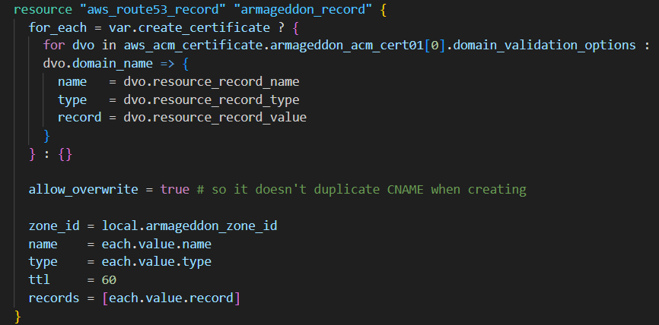
When does it create records?
- Only when var.create_certificate = true.
- Otherwise for_each = {} (empty map) → creates zero records.
What records is it creating?
- When you request an ACM cert, AWS returns domain_validation_options which include the CNAME records you must add to DNS.
- This loop builds a map of those CNAMEs keyed by dvo.domain_name (useful if you have SANs like www.domain.com, etc.)
What does allow_overwrite = true do?
- If a validation record already exists, Terraform can update it instead of failing with “record already exists.”
Where are the records created?
- In the hosted zone identified by local.armageddon_zone_id (created by Terraform or provided).
Outcome: when you create a certificate, Terraform also creates all required DNS validation CNAMEs automatically.

